Legaspi, Cesar Torrente (1917-1994)
Cesar Legaspi was a Filipino painter, known as one of the 13 Moderns, a motley group of emergent artists whose work, according to artist-art educator Victorio Edades, was an alternative to the classicism and nostalgia-laced realism popular amongst academic art educators during the pre-WWII juncture of the American colonial period. Along with his peers, Hernando Ocampo and Vicente Manansala, Legaspi was part of a generation of artists whose early image making engaged with questions of distortion and the liberties artists could take in construing reality. In the early 1950s, these painters were regarded as the ‘Neo-Realist Triumvirate’. Though they produced works dealing with the same everyday subject matter as conservative art of the period, they also unselfconsciously took from other stylistic traditions that they encountered through research and peer exchanges. In doing so they worked towards more individuated ways of rendering subjects, finding affinities with Cubism, Surrealism, and Expressionism. In the post-WWII period, theNeo-Realists manifested a cynicism toward the urbane and they resolved this visually in different ways. Legaspi’s well-known work Gadgets II (1949) from this period depicts the mutant fusing of man and machine in an age where the industrial was both feared and mythologised. This work, alongside pieces imaging the working class including stevedores, grave diggers, beggars, seasonal farm workers, and internal migrants are associated with his early Proletarian or proto-Social Realist phase.
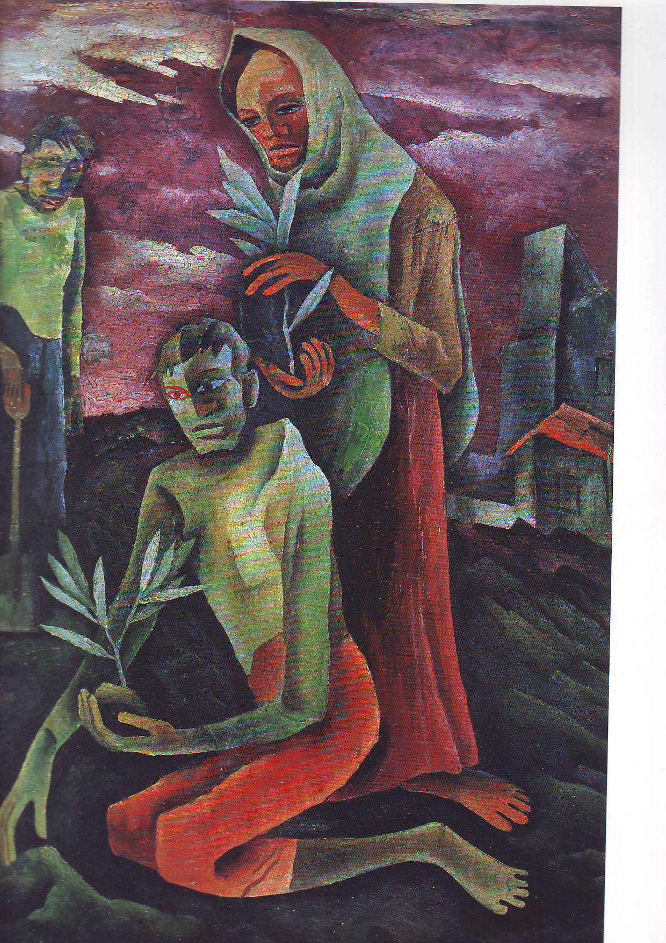
Cesar Torrente Legaspi, The Planters, 1968, Legaspi Family Collection (contact author for copyright).

The earliest of Legaspi’s major oil pieces consisted of muted earth-toned and compact compositions of figures emerging from stone forms. However, shifting from advertising to full-time painting in the1960s allowed him to further explore materials and stylistic language, including experimentations with shaped canvases, printmaking, collage and a sustained affinity with figuration and draughtsmanship. This would eventually give way to a more vibrant palette that increasingly demonstrated his interest in broader sets of ideas including more optimistic renderings of the folk themes that were generally used in the work of the conservatives and critiqued by modernists as nostalgia for the rural and pre-industrial.

Legaspi received his art education from the University of the Philippines School of Fine Arts, the Cultural Hispanica (Madrid), and the Academie Ranson in Paris, He was a representative of the Philippines to the 1967 Sao Paulo Biennials of 1967 and 1969. His acknowledged influences included Fernando Amorsolo, Carlos Francisco, and his fellow Neo-Realists, Hernando Ocampo and Vicente Manansala. Like his aforementioned colleagues, Legaspi was proclaimed National Artist for Visual Arts (1990). He passed away in 1994 from complications arising from cancer.
References and further reading
Benesa, L. (2000) What is Philippine about Philippine Art? and Other Essays. Manila: National Commission for Culture and the Arts.
Guillermo, A. (2001) “Cesar Legaspi: National Artist” in Image to Meaning: Essays on Philippine Art. Manila: Ateneo de Manila University Press.
Ledesma, P. K. and Guerrero, A. (1974) The Struggle for Philippine Art, Manila: Purita Kalaw Ledesma.
Ledesma, P. K. (1987). The Biggest Little Room, Manila: Kalaw-Ledesma Art Foundation. (
Paras-Perez, R., Benesa, Leonidas, et. al. (1983) The first Taipei exhibition of oil paintings and pen and ink drawings by Cesar F. Legaspi, Taipei: Gallery A.
_____________. (1995) Edades and the 13 Moderns, Manila: Cultural Centre of the Philippines.
Reyes, C. (1989) Conversations on Philippine Art, Manila: Cultural Center of the Philippines.
Roces, A. (1993) Legaspi: The Making of a National Artist, Hong Kong: The Crucible Workshop.

